**WEB DEVELOPMENT INTERSHIP**

**PRODUCT LANDING PAGE**

NAME**: LIKITHA V**

COLLEGE: **ASC DEGREE COLLEGE**

**Introduction**

**A** product landing page is a standalone web page created to promote and sell the product and services. This is a documentation report for a simple “Hotel Webpage”, consisting of HTML code for user interaction and CSS code for styling the webpage. The page consists of a navigation bar that links the Home, About, Service, Menu, and Contact pages.

**Home Page:** The Home Page contains a background image with a title and buttons that navigate to the other pages of the site.

**About Page:** The About Page contains the detailed information of the hotel. It contains a background image and the content is written with the help of a paragraph tag.

**Service Page:** The Service Page uses the section tag that divides the page into three sections they are the breakfast section, herbal soups section and the catering section. It contains the details of the section and learn more link that is written in the anchor tag.

**Menu Page:** The Menu Page includes the Header and Footer section. It includes the dishes that are available in the menu. It is also written in the section tag where it divides the page into small sections and it contains a button to add the items to the list.

**Contact Page:** The Contact Page includes the Name, Email id and Feedback form. The user input is taken with the help of a text box, were the user gives the review of the hotel or the website that is created.

Overall, the website has a clean and modern design with a consistent color scheme and typography. The navigation bar provides easy access to all pages of the website, and the centered titles and text provide a clear hierarchy and structure. The use of font awesome icons, hover effects, and responsive design make the website engaging and user-friendly.

This is a documentation report for a simple website consisting of the following pages:

• Home Page

• About Page

• Service Page

• Menu Page

• Contact Us Page

**Browser Compatibility**

The website has been tested and is compatible with the following browsers:

• Google Chrome

• Mozilla Firefox

• Microsoft Edge

**SOURCE CODE:**

1. **HOME PAGE**

HTML code:

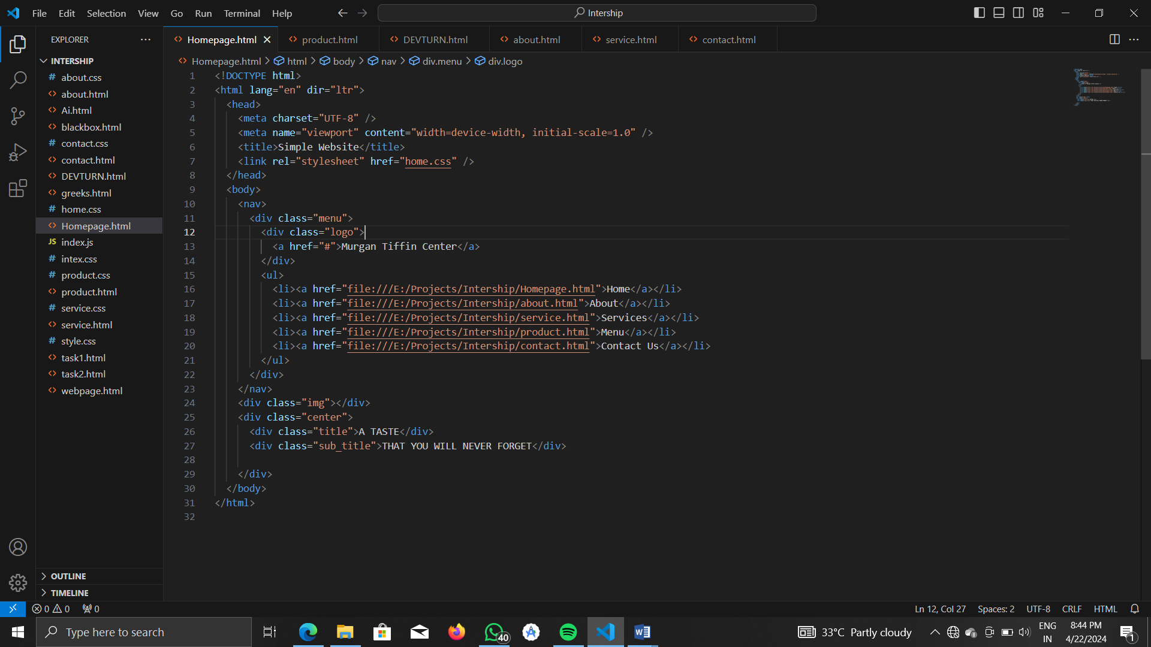

CSS code:

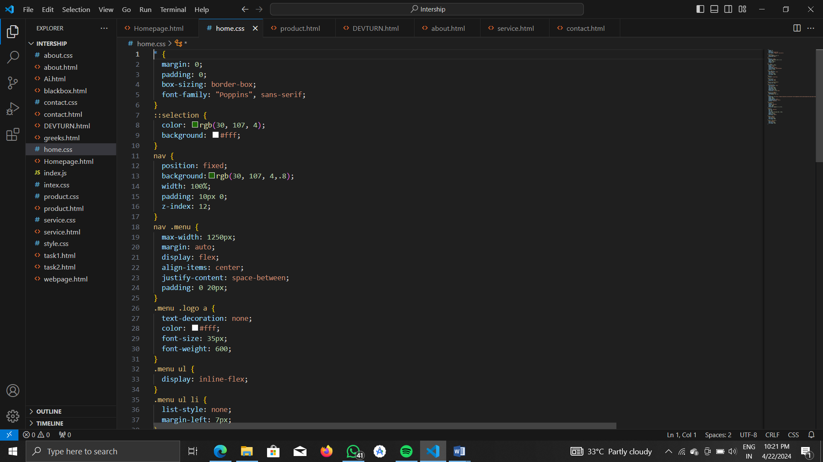

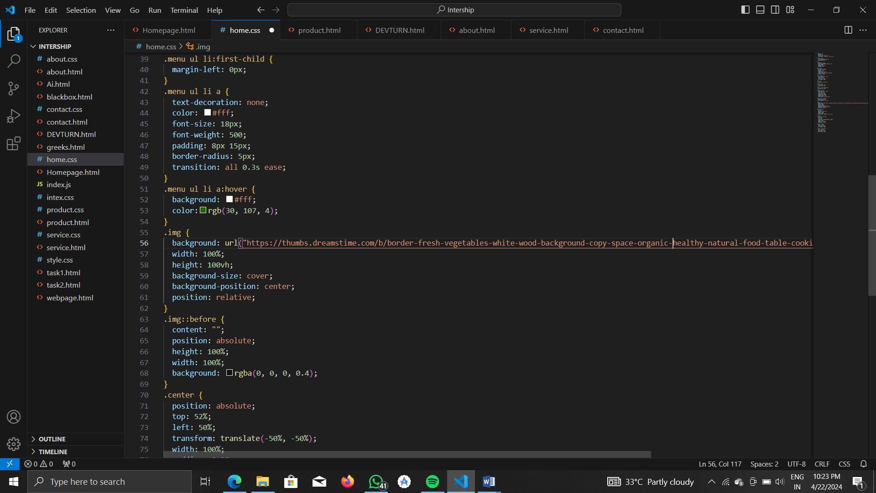

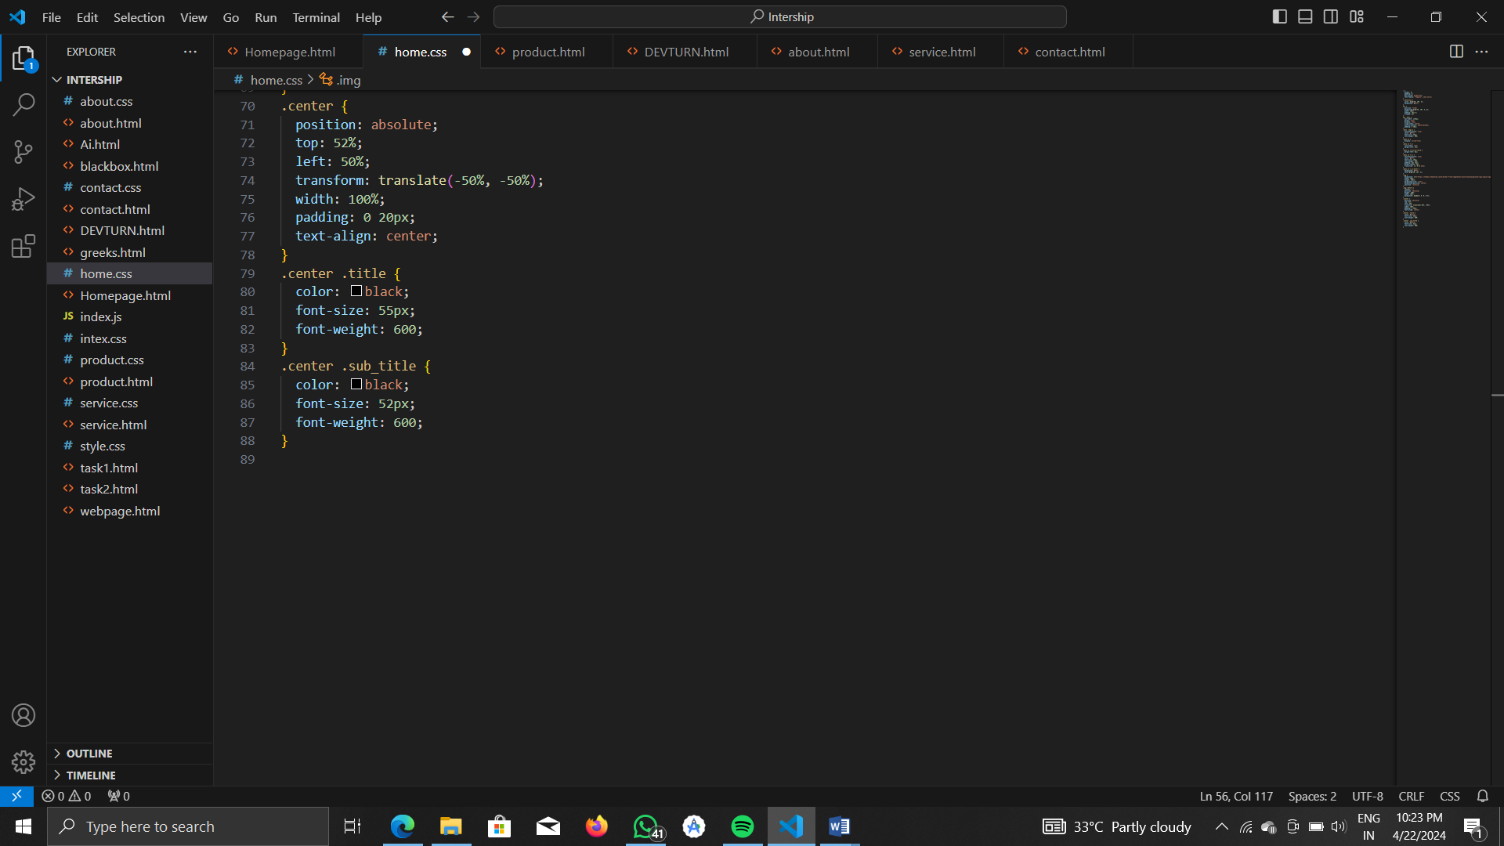

**OUTPUT:**

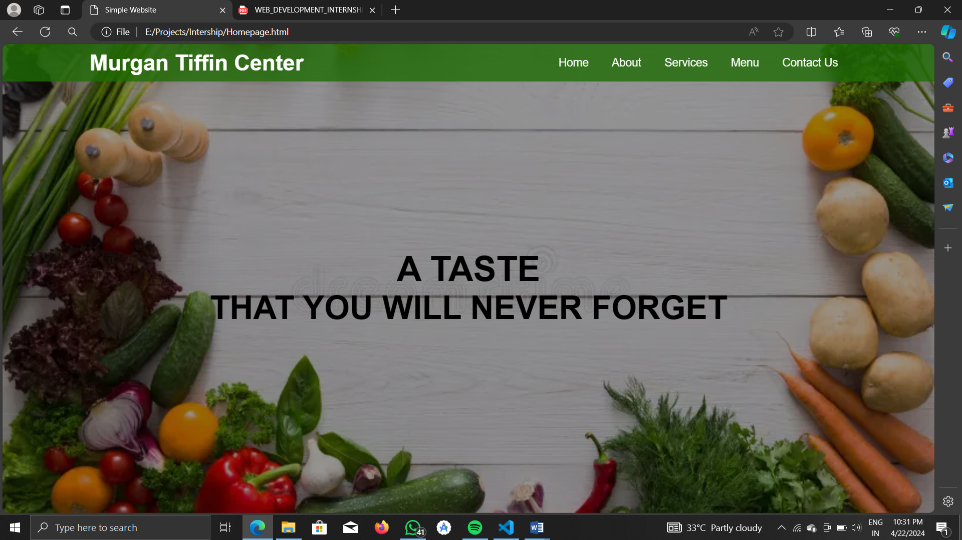

1. **ABOUT PAGE**

HTML CODE:

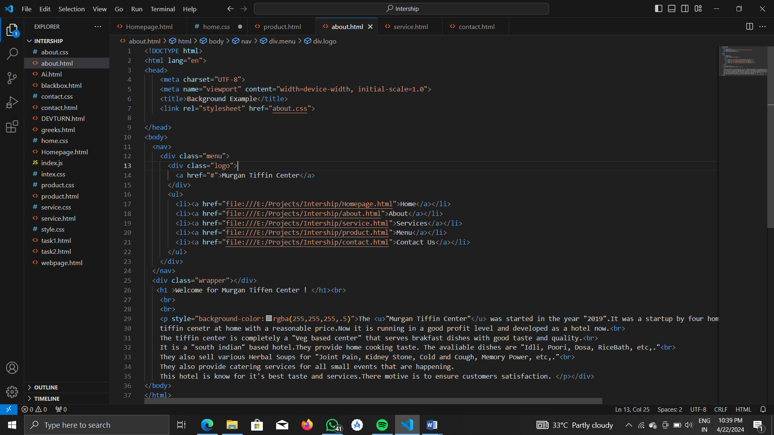

CSS CODE:

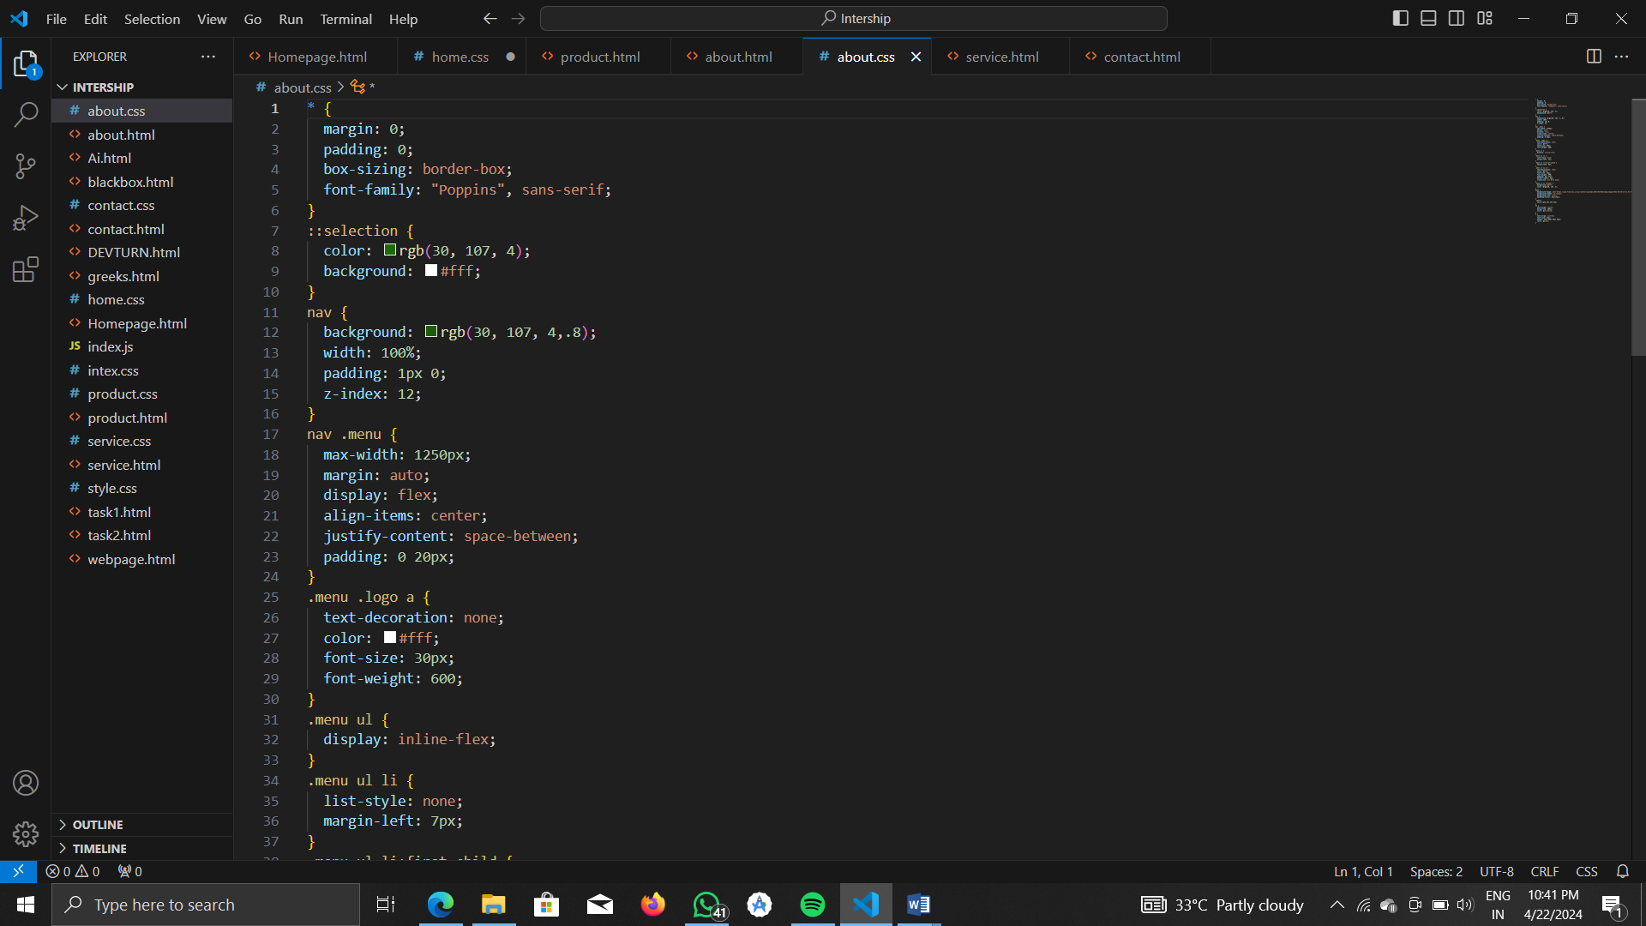

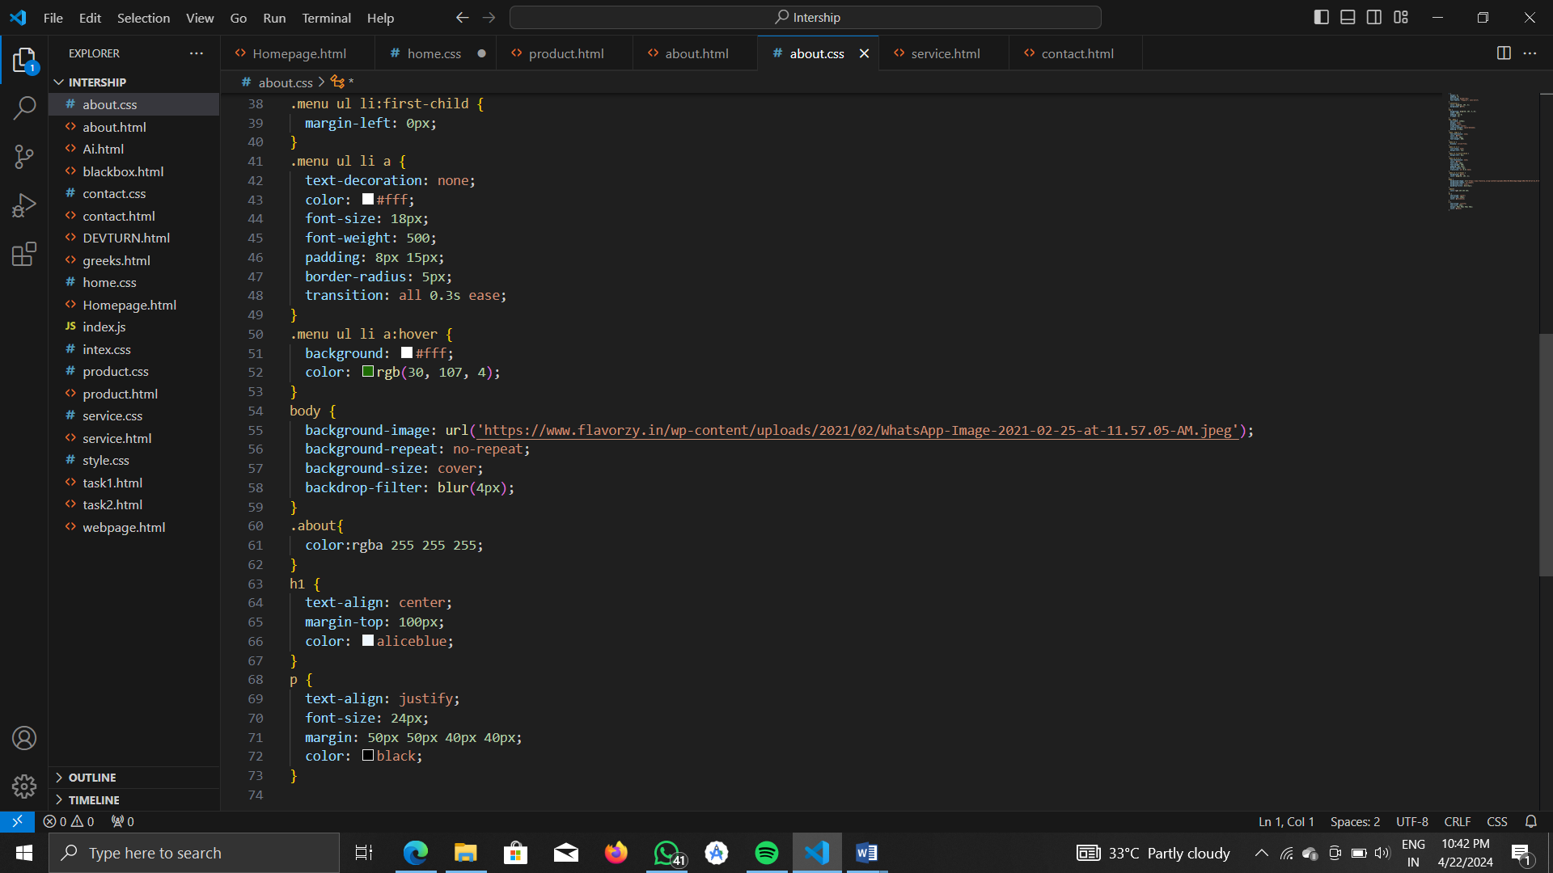

**OUTPUT:**

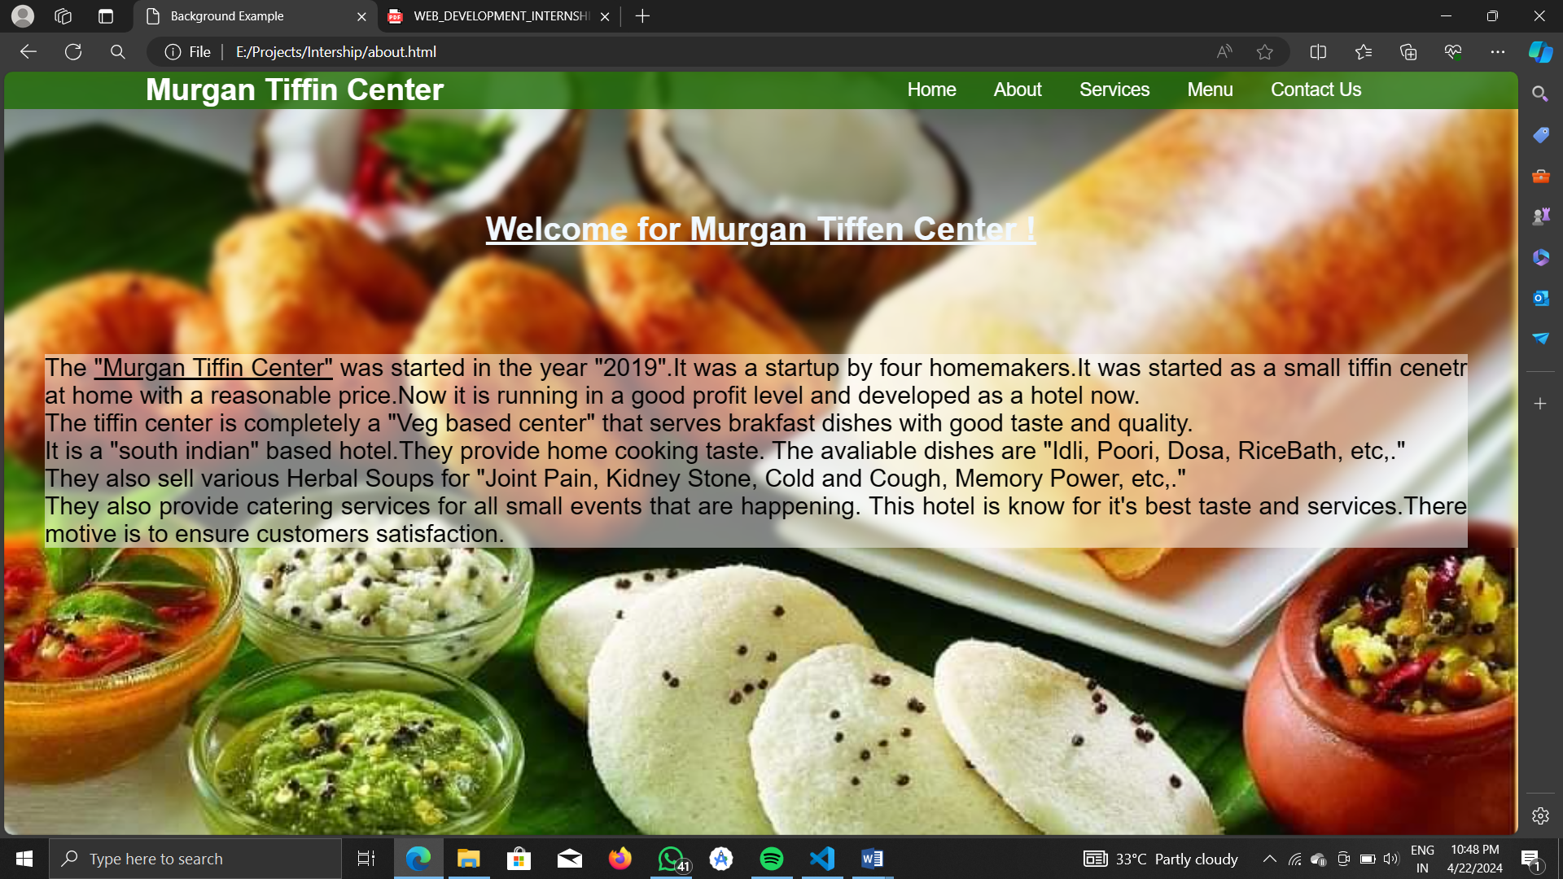

1. **SERVICES PAGE**

HTML CODE:

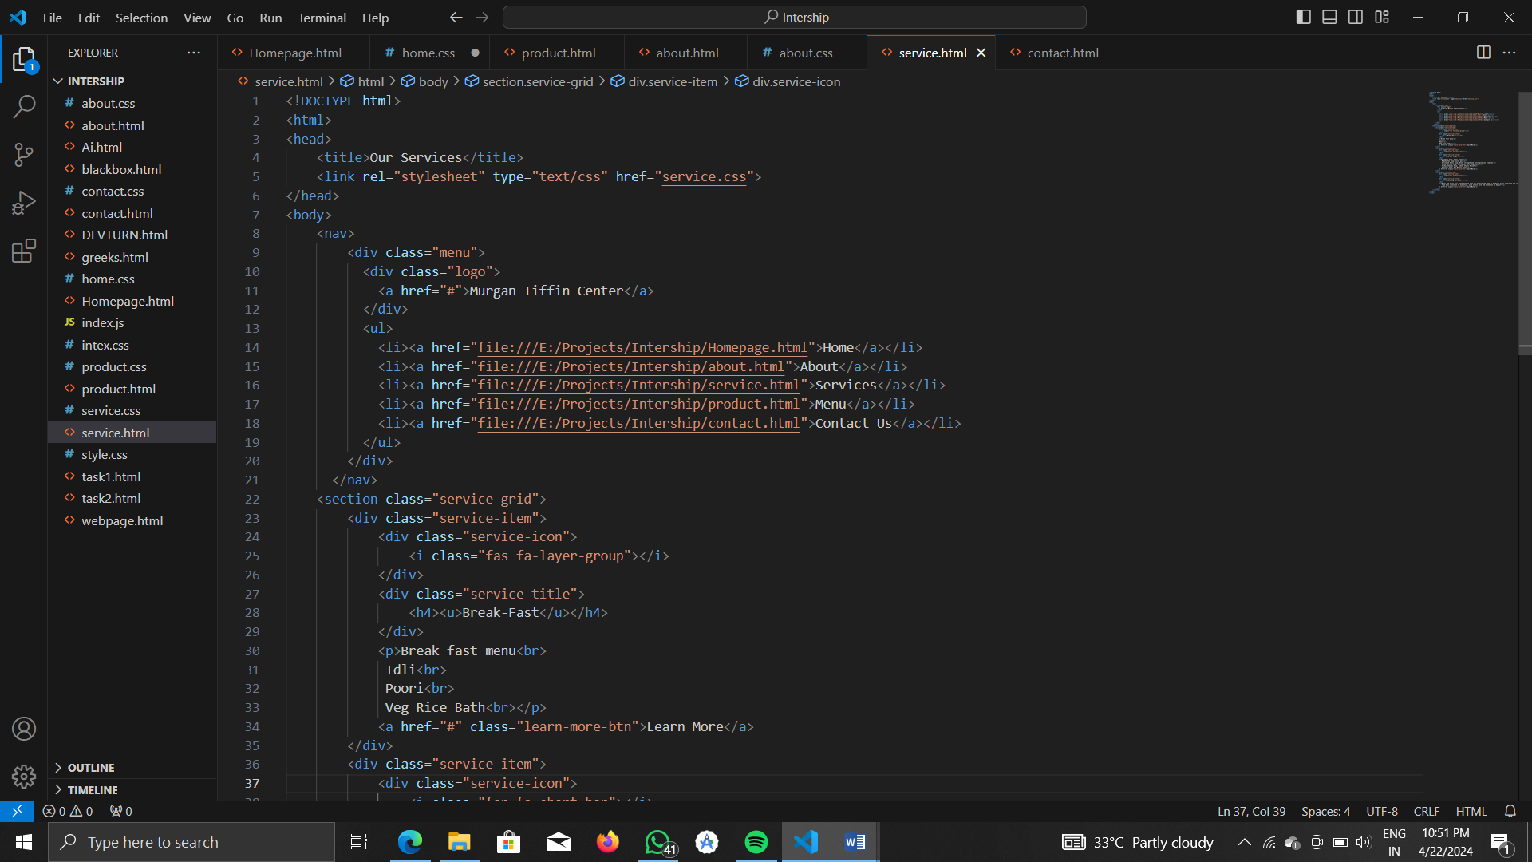

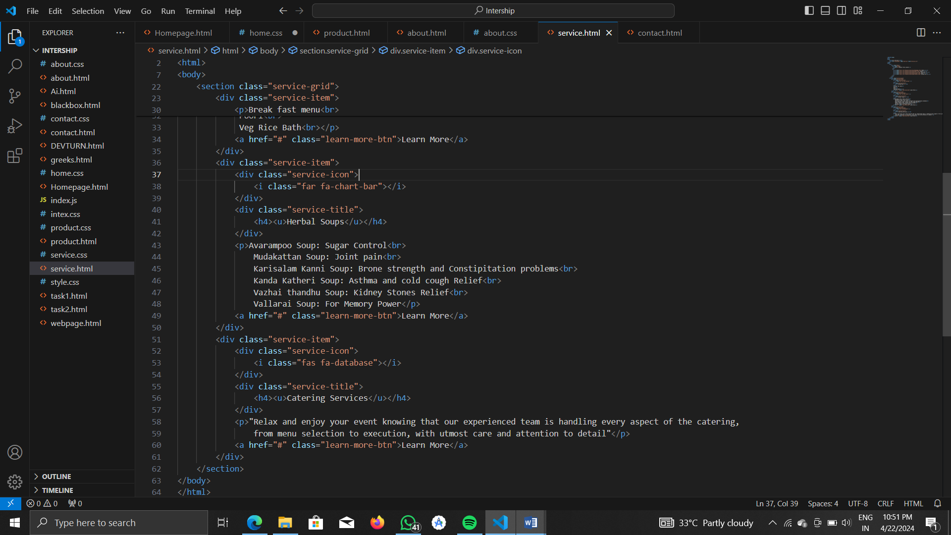

CSS CODE:

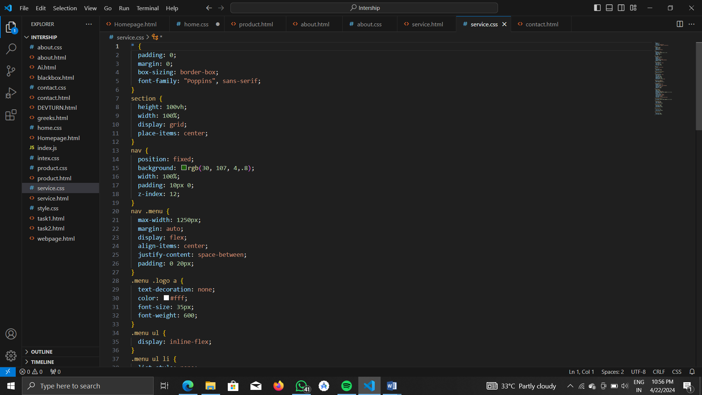

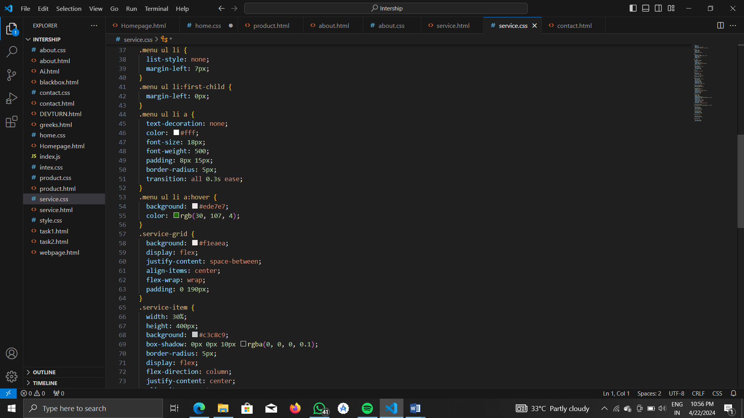

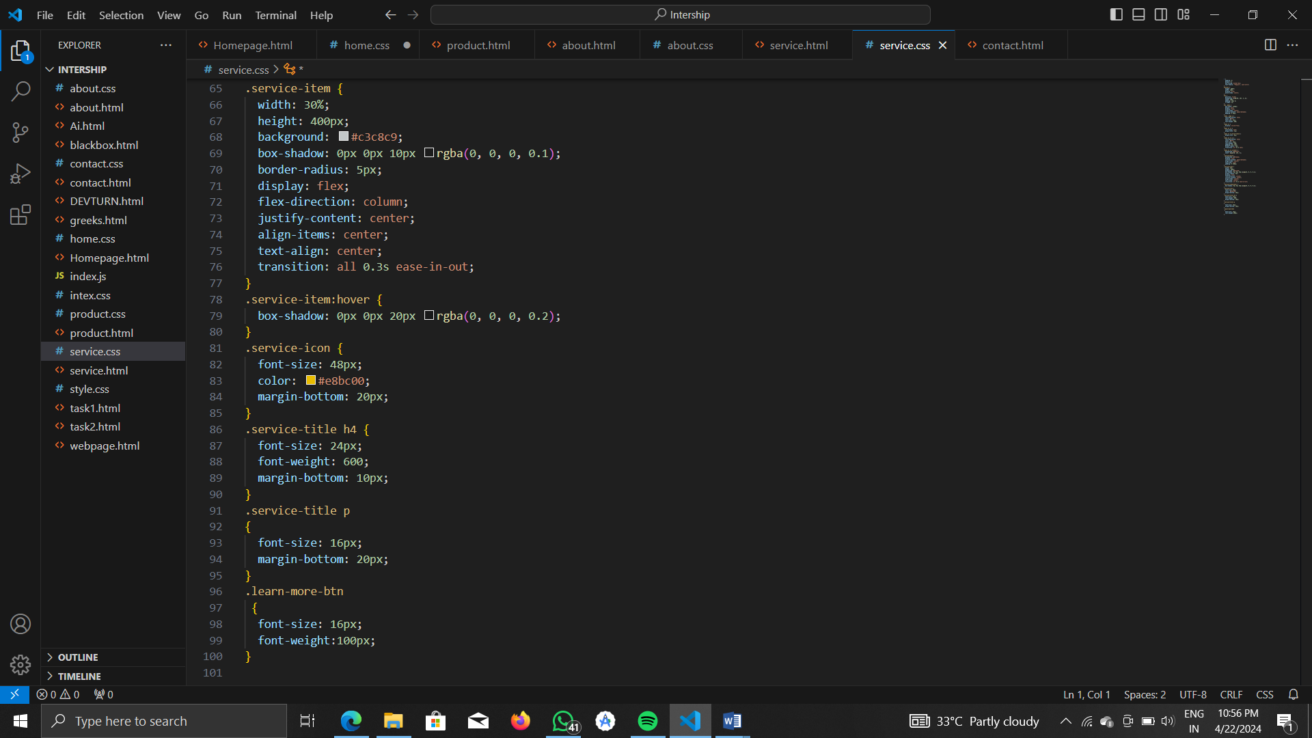

**OUTPUT:**

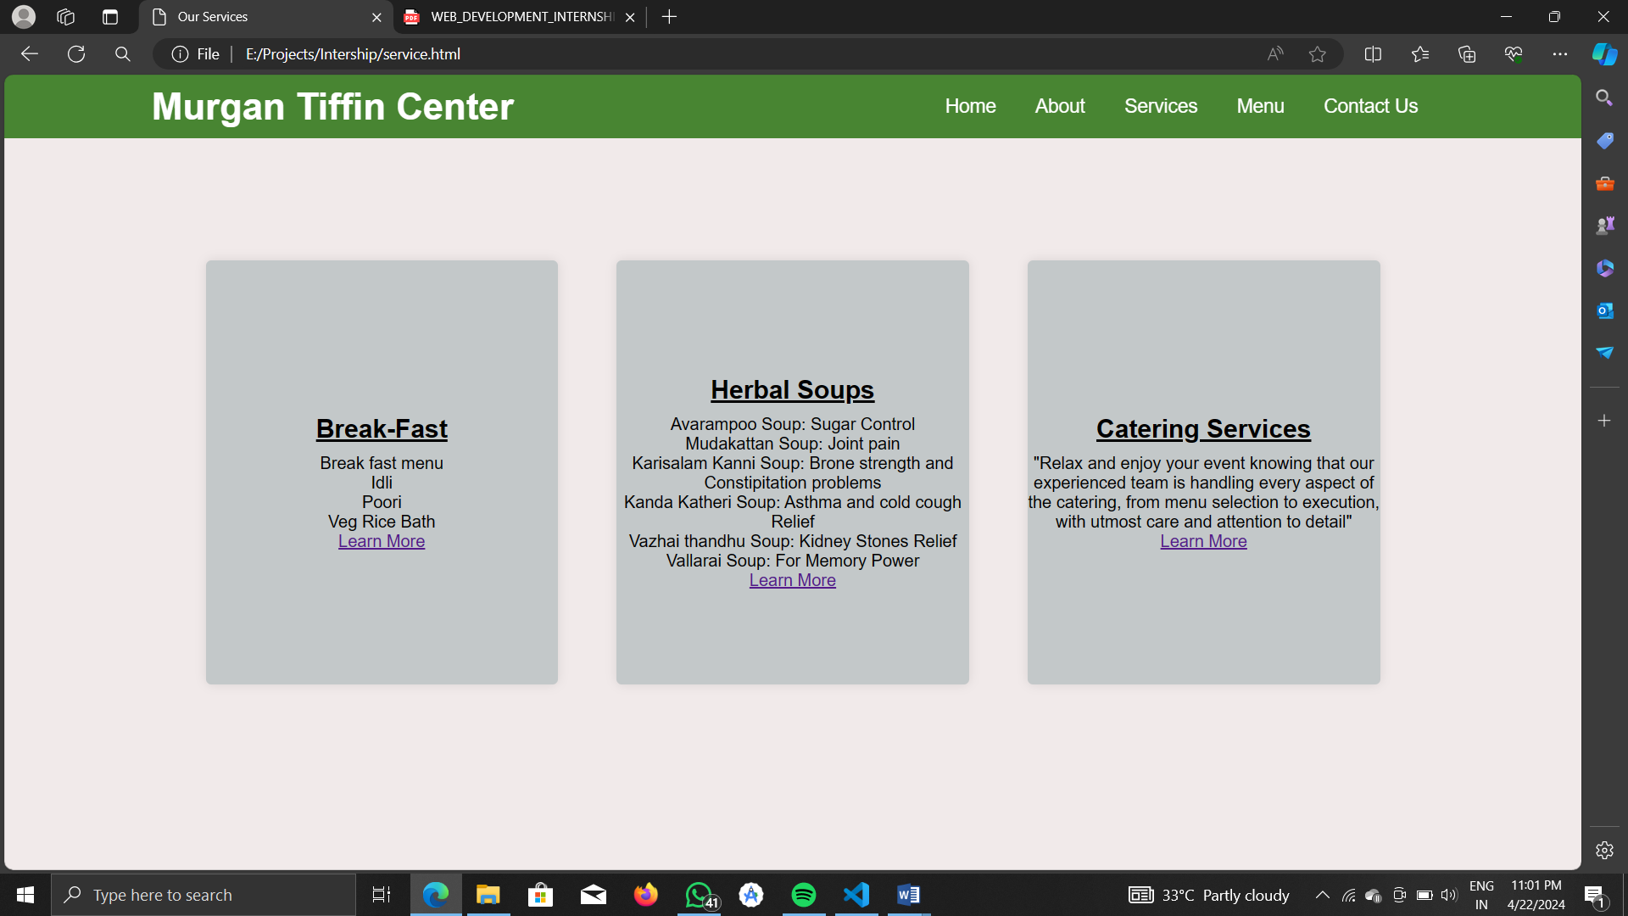

1. **MENU PAGE**

HTML CODE:

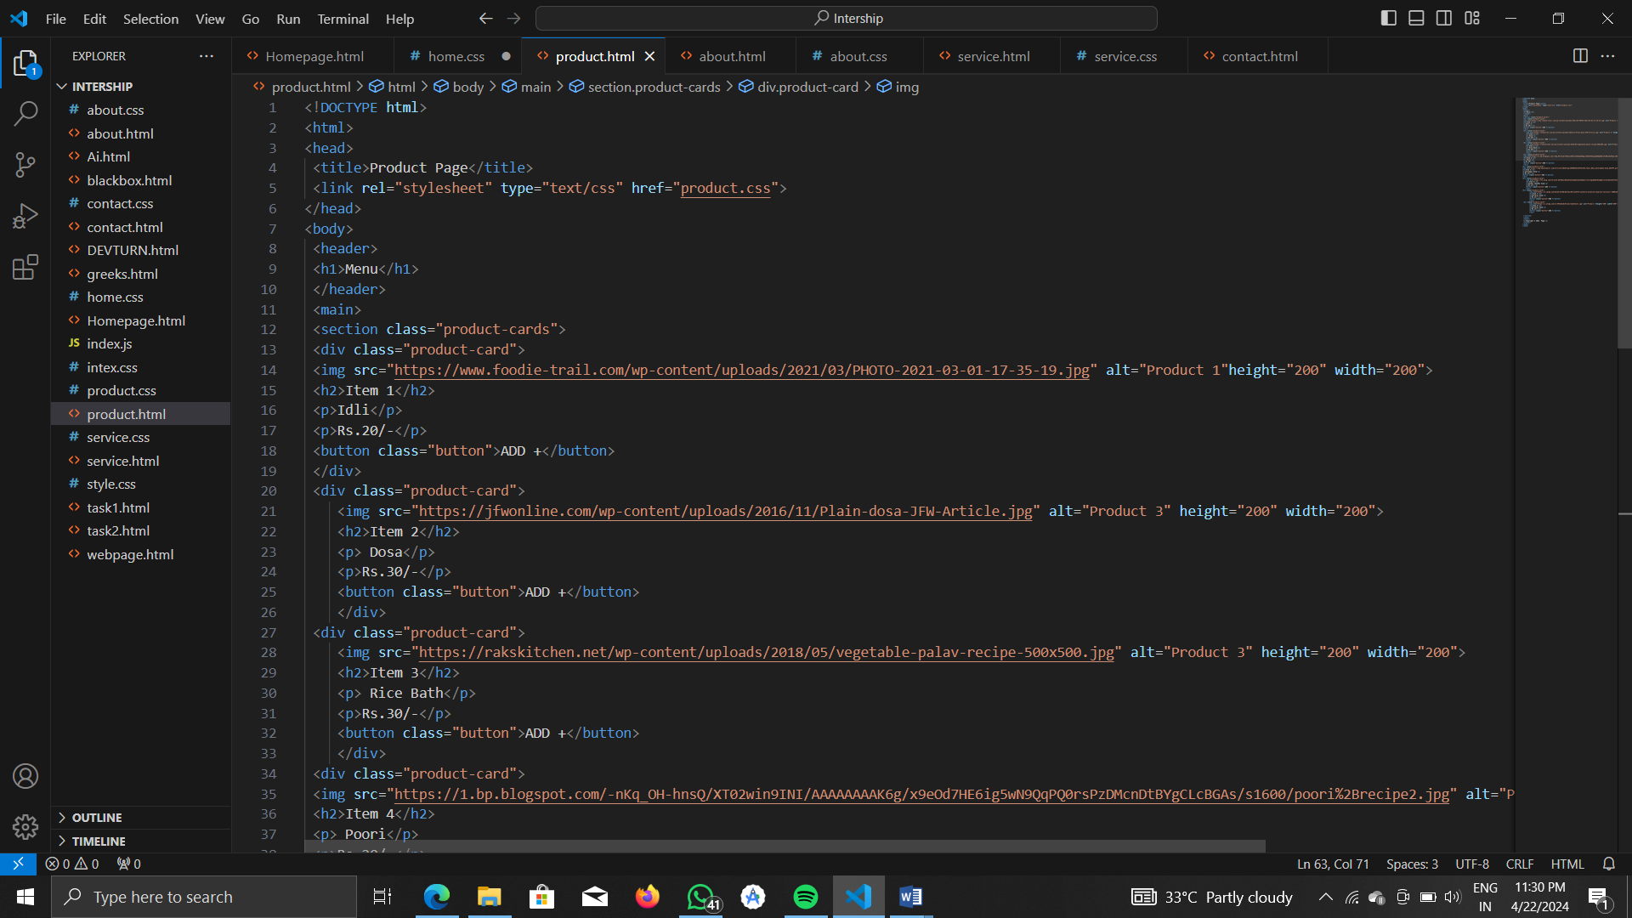

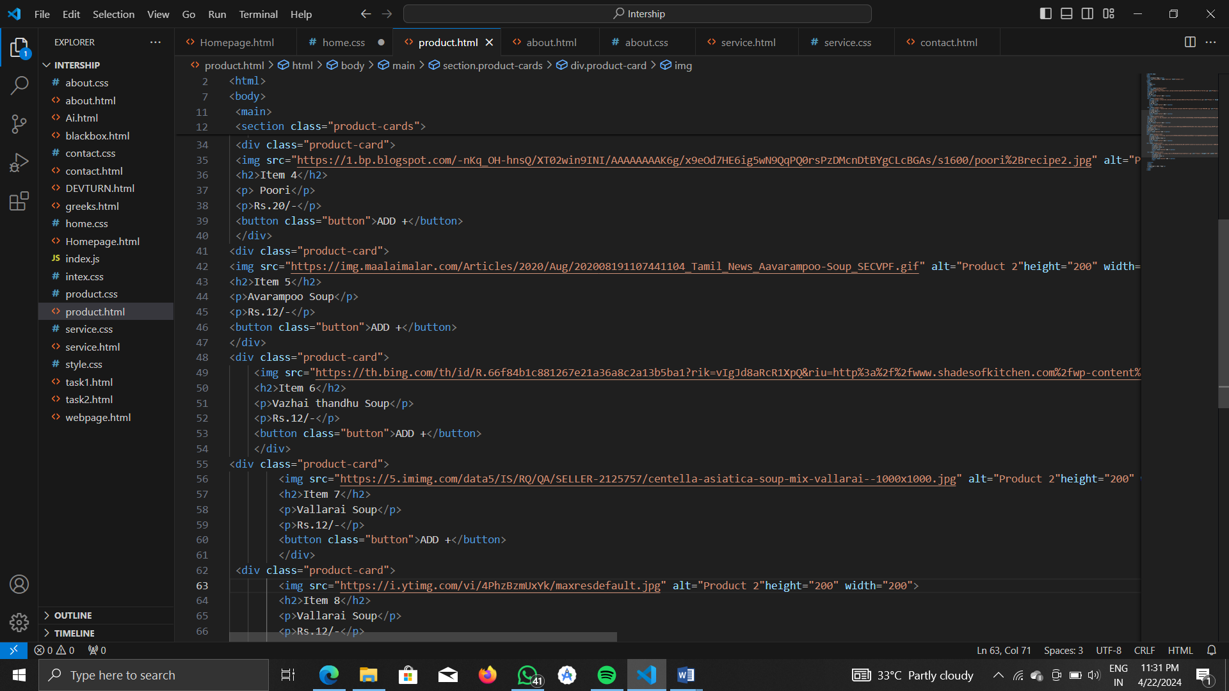

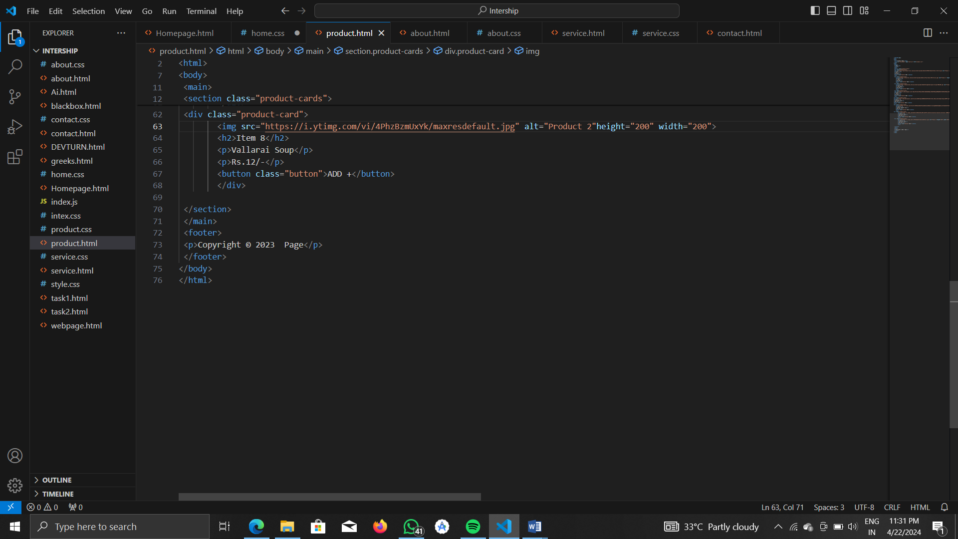

CSS CODE:

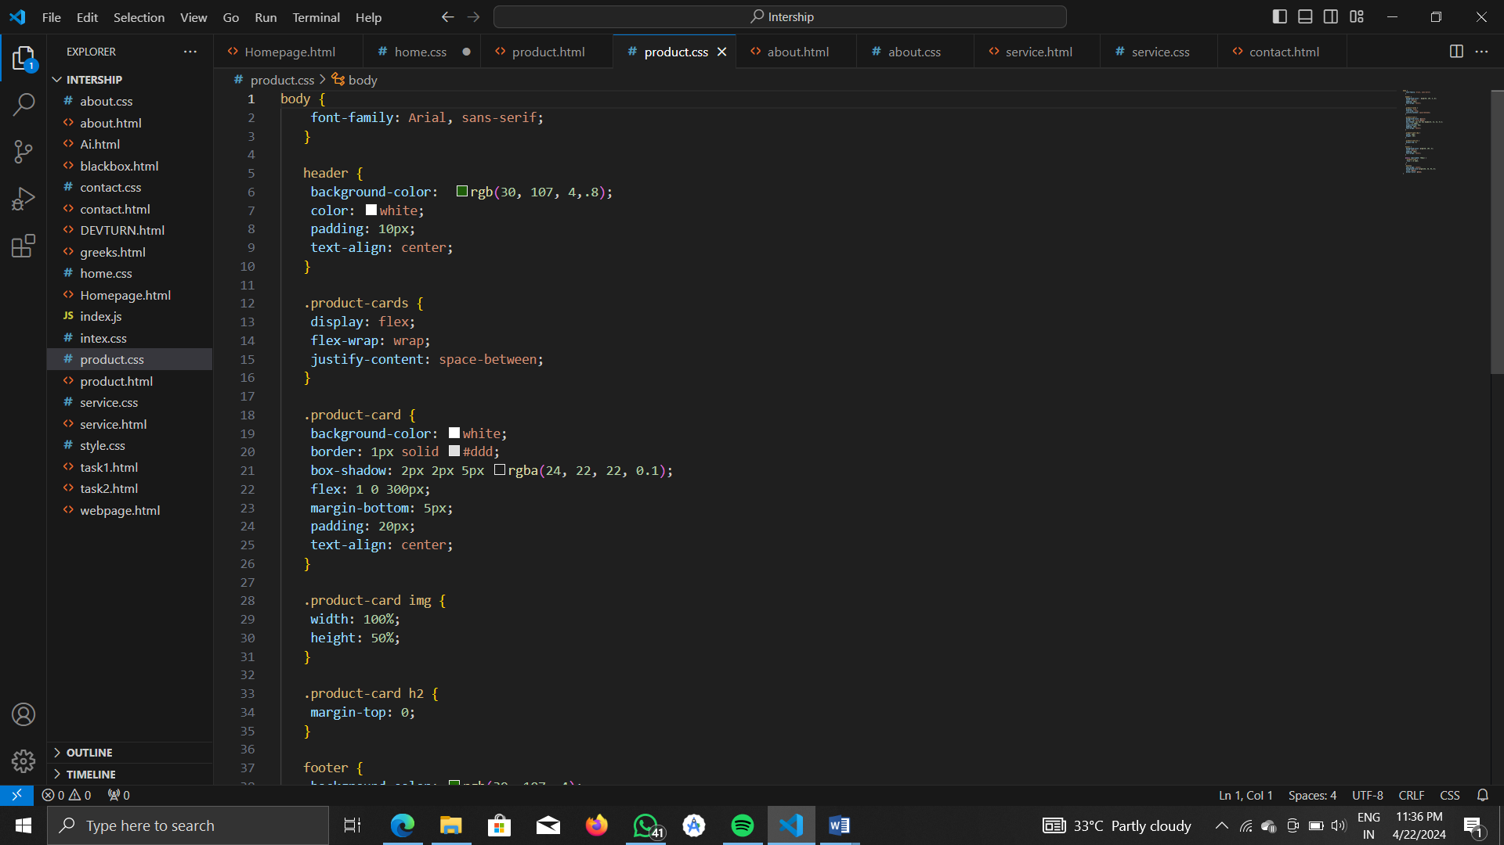

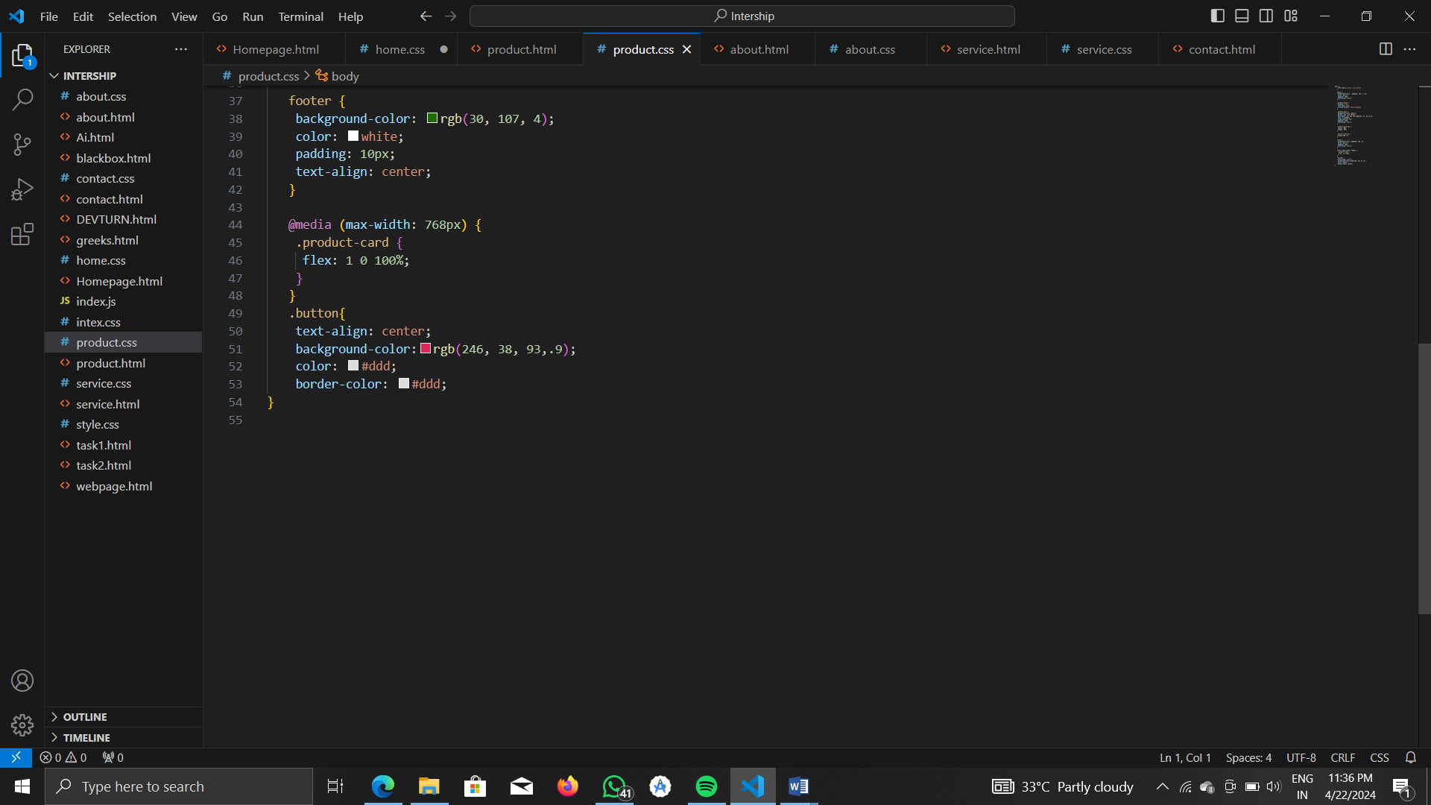

**OUTPUT:**

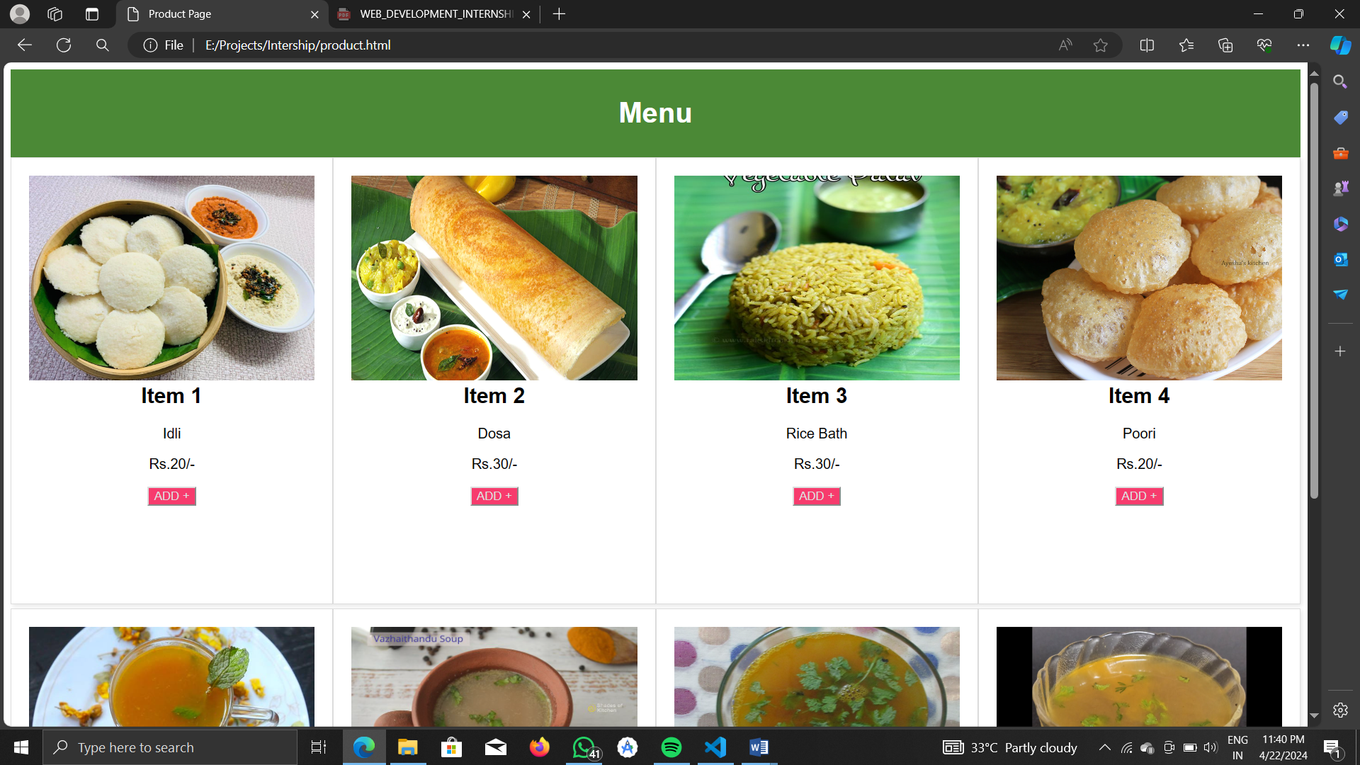

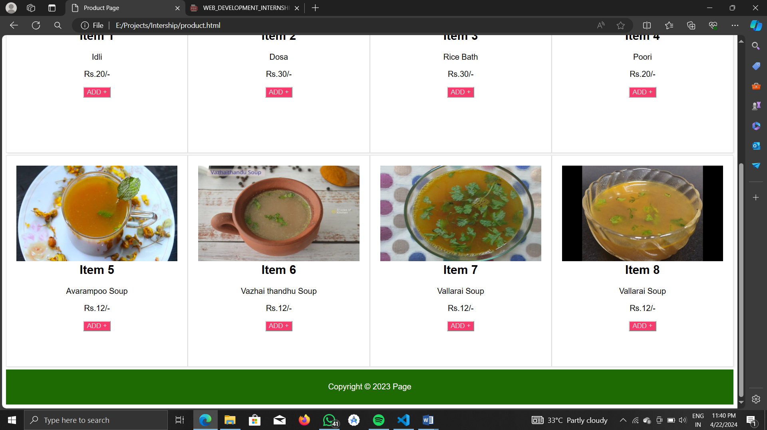

1. **CONTACT PAGE**

HTML CODE:

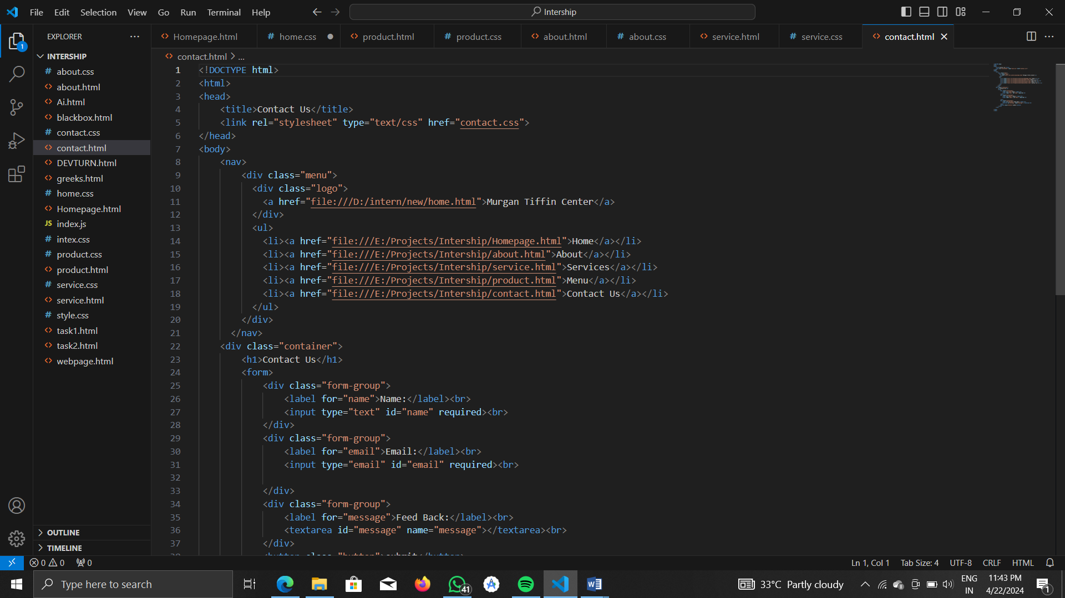

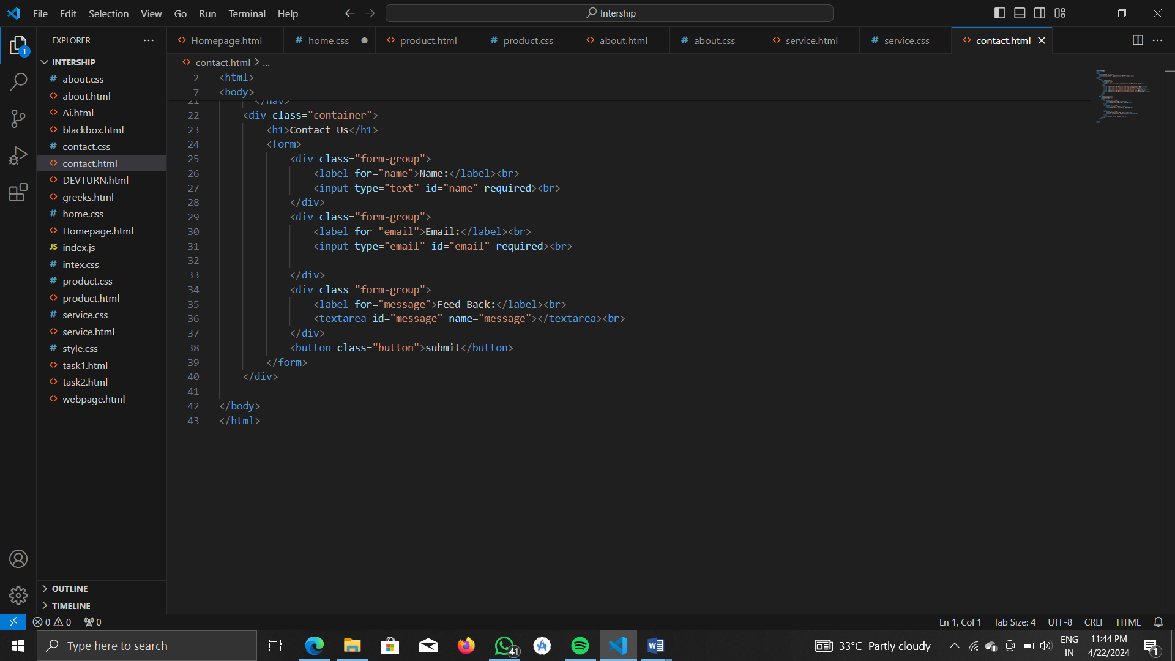

CSS CODE:

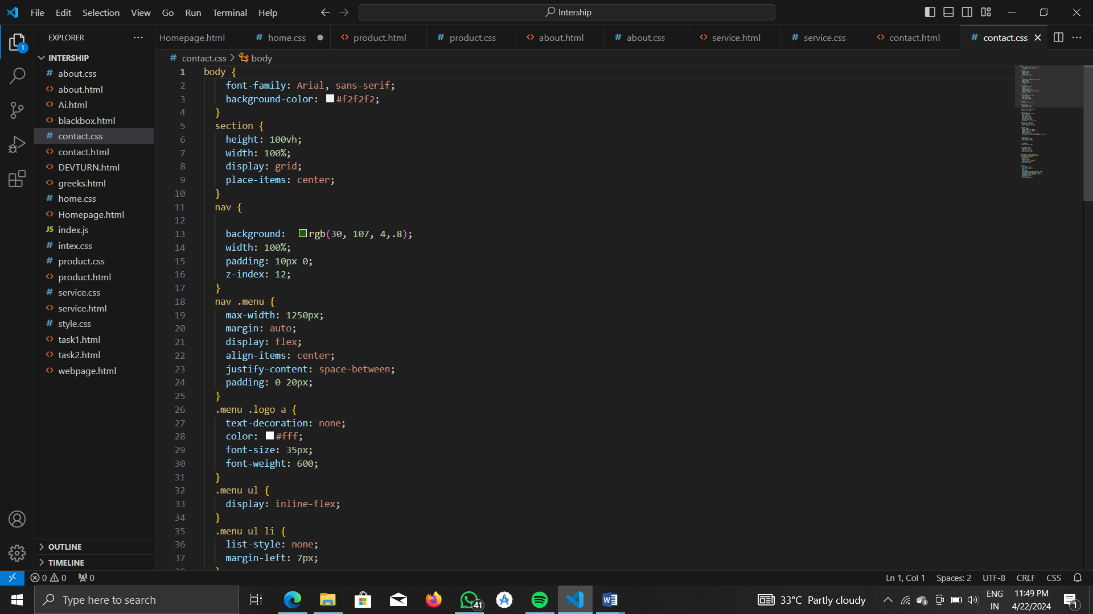

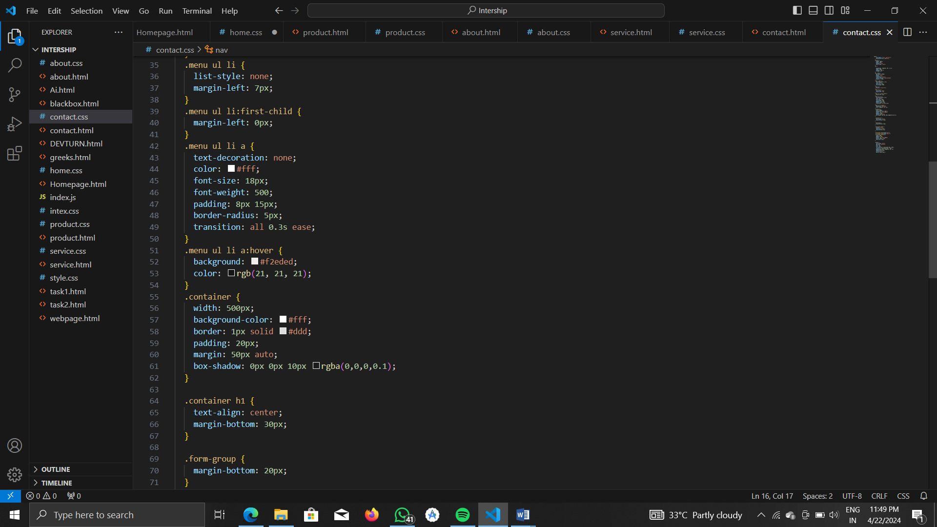

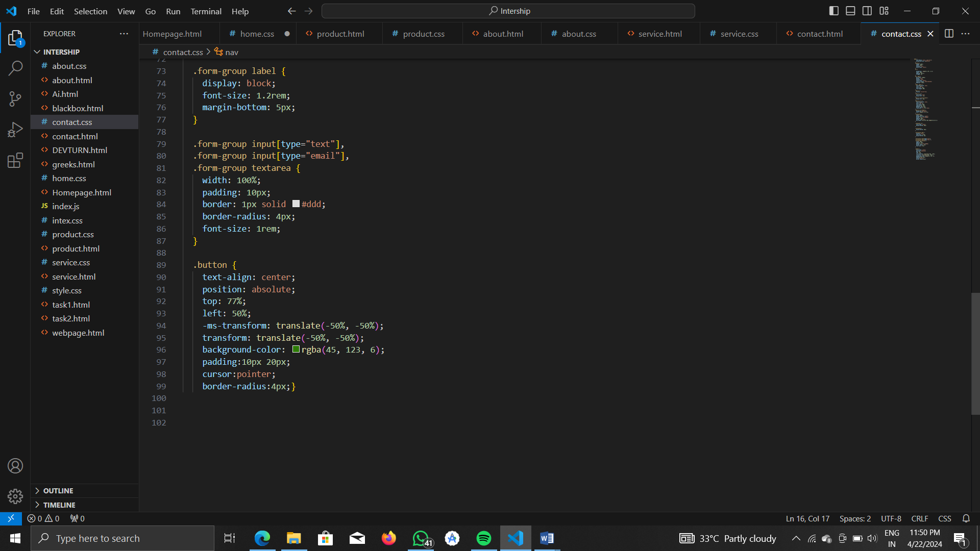

**OUTPUT:**

